c

Columbus Healthcare system
Name
Institution
Course
Instructor
Date

Columbus Georgia
The ideal healthcare system has not yet been achieved in many cities. The healthcare systems in many states in the US do not provide comprehensive services for each person living in the city. Columbus has a population of 196000 with most of them earning median household income. the median income in the state is $45,389 per year with the male employees making 1.36 more than the female employees. The healthcare system in the city provides healthcare services to numerous people even outside the city. The high number of people visiting the state has increased the waiting time to receive services from a doctor or a nurse (Park, & Guldmann, 2020).
Map
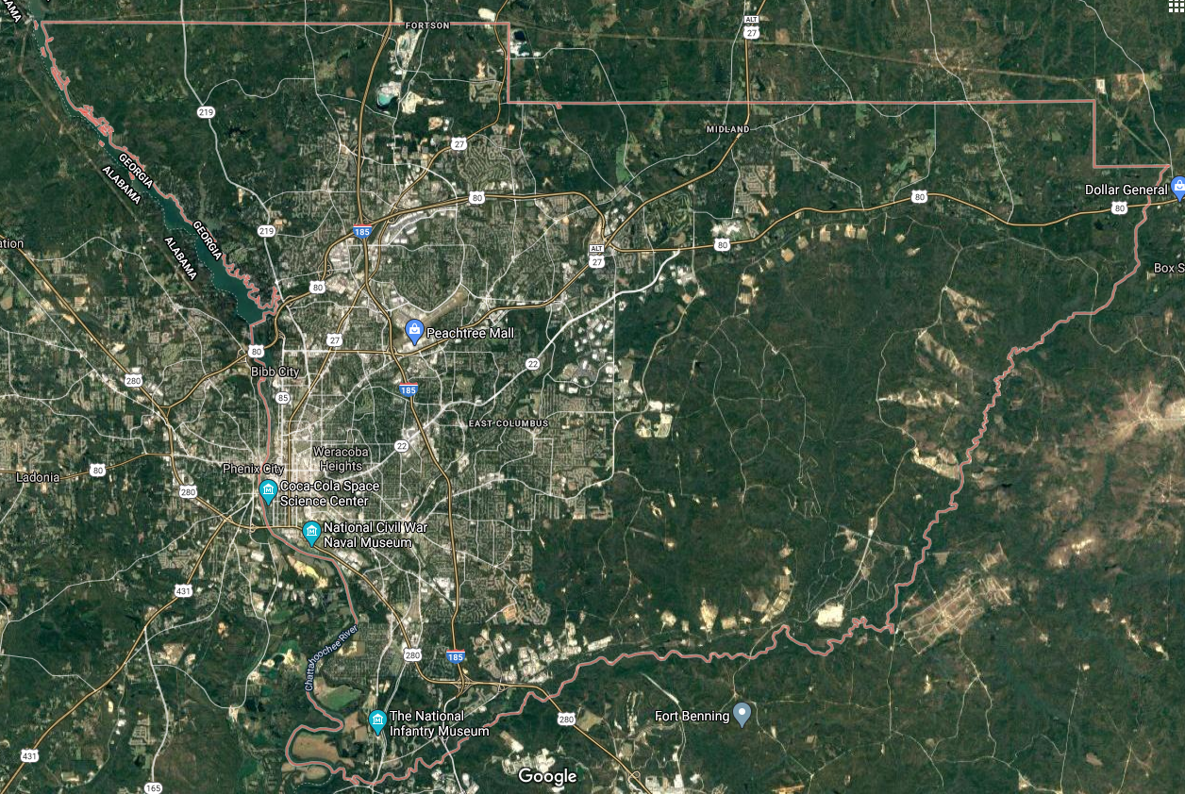
Situation
The COVID-19 pandemic has undermined the ability of most healthcare systems to efficiently providing services. Columbus is one of the cities which have experienced the impact of the pandemic. The city has various hospital reliable in providing many services (Mercier, Arquizan, & Roubille, 2020). The healthcare system of the town is just efficient in serving the needs of the people living in the town. This means the city has a healthcare system that can serve a population of people below 200,000. In recent years, many people residing in cities close to Columbus have been seeking better medical attention in the hospitals within the city. This has generally led to congestion in the hospitals with more individuals seeking to receive service at the same time. This has led to increased waiting time to almost double due to more people being serviced. There also has been a shortage of beds in the hospitals making the problem even worse.

Background
The amount of time one waits in the hospital before receiving the services they need can indicate how efficient the operations within the hospital are. The increase in the general amount of time one has to wait in line before receiving services shows inefficiency in the delivery of services. Increased waiting time has also increased congestion in the hospitals which can be risky especially during the COVID-19 pandemic. The COVID-19 has also increased the demand for healthcare services making it even more necessary to provide interventions for increasing the efficiency of service delivery (Mercier, Arquizan, & Roubille, 2020).

Assessment
The increase in waiting time shows that the number of people receiving services from the hospitals has increased. As many people living outside Columbus have been relying on the healthcare services in the city, more hospitals are likely to be congested. The number of healthcare service providers in the state has remained the same regardless of the increase in demand. This means the service providers have to provide services to more individuals than before. The number of hospital beds available has also decreased due to the increased population receiving the admission services in the city. There is a need to increase the number of health service providers and hospital beds in the hospitals around the city.
Recommendations
The department of health in the city of Columbus can enact various interventions as a way of alleviating the problems associated with the increased demand for healthcare services in the city. Congestion and a low number of vacant hospital beds are some of the key problems associated with the increased demand for healthcare services. The department of health can create 100 more vacancies in the city to help in the provision of services. Distributing the service providers across the different hospitals in the city can help with alleviating the congestion problem (AbuAlRub, 2017). The average annual salary for service providers in Columbus including registered nurses and doctors is $64,097. The annual salary for the 100 additional service providers in the city would be $6400000. This would help in reducing the waiting time as well as congestion in the hospitals. There is a need to increase the number of hospital beds available in the city. 500 hospital beds would cost the healthcare department $887000. These two measures with help in improving the efficiency of service delivery during the pandemic period.
Conclusion
The COVID-19 has undermined the efficiency of many healthcare systems in the delivery of services (Mercier, Arquizan, & Roubille, 2020). Based on the various assessments conducted, the department of health in the city of Columbus has a role to play in improving the efficiency in service delivery in various hospitals within the city. The advised short-term interventions include increasing the number of service providers and number of hospital beds to supplement the available ones. Increased efficiency in service delivery will increase the general state of public health in the city.

References
AbuAlRub, R. F. (2017). The nursing shortage: what is the solution?. Journal of Professional Nursing, 23(2), 117-120.
Mercier, G., Arquizan, C., & Roubille, F. (2020). Understanding the effects of COVID-19 on health care and systems. The Lancet Public Health, 5(10), e524.
Park, Y., & Guldmann, J. M. (2020). Understanding disparities in community green accessibility under alternative green measures: A metropolitan-wide analysis of Columbus, Ohio, and Atlanta, Georgia. Landscape and Urban Planning, 200, 103806.

